Paul Sarbanes

**From Wikipedia, the free encyclopedia**

https://en.wikipedia.org/wiki/Paul%20Sarbanes  
Licensed under CC BY-SA 3.0:  
https://en.wikipedia.org/wiki/Wikipedia:Text_of_Creative_Commons_Attribution-ShareAlike_3.0_Unported_License

# Paul Sarbanes

* *Sarbanes was the longest-serving senator in Maryland history until he was surpassed by Barbara Mikulski by a single day when her term ended on January 3, 2017.*
* *Elected to the Maryland House of Delegates in 1966, he went on to serve two terms in the Maryland House from 1967 to 1971.*
* *Sarbanes was known for his low-key style, often shunning the limelight over his 30-year Senate career.*

Paul Spyros Sarbanes (born February 3, 1933) is an American former politician and attorney. A member of the Democratic Party from Maryland, he served as a member of the United States House of Representatives from 1971 to 1977 and as a United States Senator from 1977 to 2007. Sarbanes was the longest-serving senator in Maryland history until he was surpassed by Barbara Mikulski by a single day when her term ended on January 3, 2017.

Born in Salisbury, Maryland, Sarbanes is a graduate of Princeton University, Balliol College, Oxford, and Harvard Law School. Elected to the Maryland House of Delegates in 1966, he went on to serve two terms in the Maryland House from 1967 to 1971. In 1970, he won a seat in the United States House of Representatives, representing Maryland's 4th and later Maryland's 3rd congressional district from 1971 to 1977. In 1976, he ran for the United States Senate, defeating Republican incumbent John Glenn Beall, Jr. with 59% of the vote. Sarbanes was re-elected four times, each time receiving no less than 59% of the vote. He did not seek re-election in 2006, when he was succeeded by fellow Democrat Ben Cardin. Sarbanes was known for his low-key style, often shunning the limelight over his 30-year Senate career. In 2002, Sarbanes co-sponsored the Sarbanes–Oxley Act, which is cited as his most-noted sponsored piece of legislation.

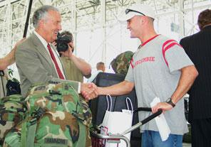  
*Senator Sarbanes congratulates US troops as they depart the new state-of-the-art USO International Gateway Lounge at Thurgood Marshall BWI airport.*

# Early life and family

* *His son, John Sarbanes, won the general election for Maryland's 3rd congressional district in 2006, the district that Paul Sarbanes represented prior to his election as senator.*
* *In June 1960, Sarbanes married Christine Dunbar of Brighton, England; they have three children (John Sarbanes, Michael Anthony Sarbanes, and Janet Matina Sarbanes) and seven grandchildren.*

Paul Sarbanes was born on Maryland's Eastern Shore in the city of Salisbury to Greek parents, Matina (née Tsigounis) and Spyros P. Sarbanes, who had emigrated from Laconia, Greece and owned a Salisbury restaurant.

A graduate of Wicomico High School in Salisbury, Maryland, Sarbanes attended Princeton University, earning a bachelor's degree in 1954. As a senior, he received the Moses Taylor Pyne Honor Prize, Princeton's highest undergraduate honor. He also was awarded a Rhodes Scholarship that brought him to Balliol College of the University of Oxford in Oxford, England, graduating with a First Class degree in 1957. Sarbanes then returned to the United States and attended Harvard Law School.

After graduating in 1960, he clerked for Federal Judge Morris A. Soper before entering private practice with two Baltimore, Maryland law firms. In June 1960, Sarbanes married Christine Dunbar of Brighton, England; they have three children (John Sarbanes, Michael Anthony Sarbanes, and Janet Matina Sarbanes) and seven grandchildren. Christine Sarbanes died of cancer on March 22, 2009. Sarbanes holds the highest lay office in the Greek Orthodox Church, "Order of St. Andrew, Archon of the Ecumenical Patriarchate" and is a member of the Greek Orthodox Cathedral of the Annunciation in Baltimore.

His son, John Sarbanes, won the general election for Maryland's 3rd congressional district in 2006, the district that Paul Sarbanes represented prior to his election as senator.

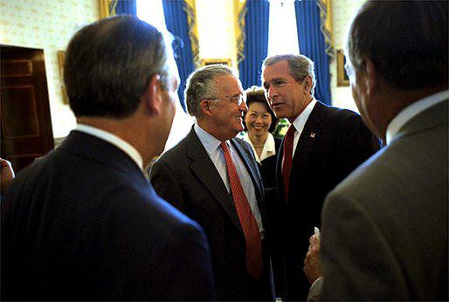  
*Before the signing ceremony of the Sarbanes-Oxley Act, President George W. Bush meets with Senator Sarbanes, Secretary of Labor Elaine Chao and other dignitaries in the Blue Room of the White House July 30, 2002.*

# Political career

* *In 1976, Sarbanes was elected to the United States Senate and re-elected in 1982, 1988, 1994 and 2000.*
* *Sarbanes served on the following Senate committees:*
* *In 1966, Sarbanes ran for the Maryland House of Delegates in Baltimore City and won.*
* *While in the House, Sarbanes served on the Judiciary Committee, the Merchant Marine and Fisheries Committee, and the Select Committee on House Reorganization.*

In 1966, Sarbanes ran for the Maryland House of Delegates in Baltimore City and won. During his four years as a State delegate in Annapolis, Maryland he served on both the Judiciary and the Ways and Means Committees.

He was elected to the United States House of Representatives in 1970 from the fourth district of Maryland and was reelected in 1972 and 1974 from the third district. While in the House, Sarbanes served on the Judiciary Committee, the Merchant Marine and Fisheries Committee, and the Select Committee on House Reorganization. It was during his service in the House, in August 1974, that Sarbanes was selected by his Democratic colleagues on the House Watergate Committee to introduce the first Article of Impeachment, for obstruction of justice, against President Richard Nixon.

In 1976, Sarbanes was elected to the United States Senate and re-elected in 1982, 1988, 1994 and 2000. In 2002, Sarbanes was the Senate sponsor of the Sarbanes-Oxley Act of 2002, which reformed federal securities laws in the wake of the 2002 accounting scandals.

Sarbanes served on the following Senate committees:

Ranking Member of the Banking, Housing and Urban Affairs Committee

Ranking Member of the Special Whitewater Committee.

Senior Member Foreign Relations Committee.

Senior Member Budget Committee.

Senior Member Joint Economic Committee.

By 1981, Sarbanes was noted as a frequent critic of military budgets. In spite of this, in May of that year, he voted in favor of approving a Reagan administration-backed $136.5 billion military authorization bill. In December, he voted in favor of an amendment to President Reagan's MX missiles proposal that would divert the silo system by $334 million as well as earmark further research for other methods that would allow giant missiles to be based. While the military authorization bill was seen as supporting the administration, the December vote was viewed as a rebuff of Reagan.

On March 11, 2005, Sarbanes, the longest-serving senator in Maryland history, announced at a news conference his decision not to seek re-election in 2006. Colleagues of Sarbanes said that the reason for his retirement from the Senate was due to his annoyance with not having any leadership roles on committees. When the 110th Congress convened in 2007, he was succeeded by fellow Democrat Ben Cardin who won   
the 2006 election.

The Senator received the Foreign Language Advocacy Award in 2007 from the Northeast Conference on the Teaching of Foreign Languages in recognition of his lifelong commitment to the values, languages, and cultures of the ancient world in service to the modern world.

# Election history

# Publications

* *"The premise of the U. S. Constitutional system," Perspectives on culture and society, vol.*
* *1 (1988), 119–126*

"The premise of the U. S. Constitutional system," Perspectives on culture and society, vol. 1 (1988), 119–126

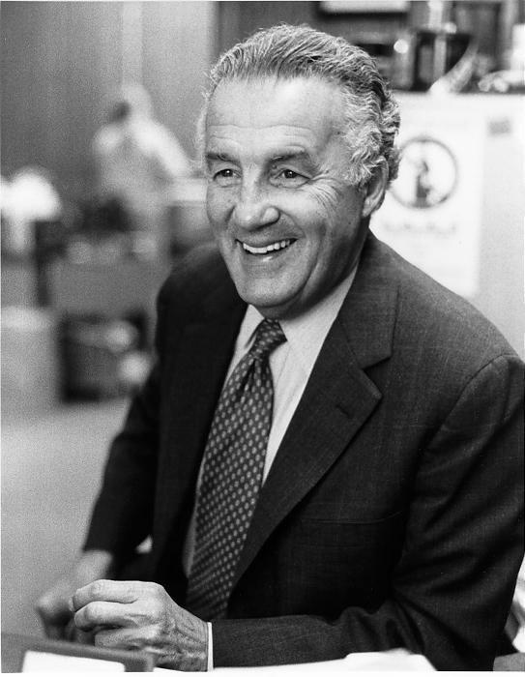  
*Earlier photograph of Senator Sarbanes.*

# References

# External links

* *"Paul Sarbanes (id: S000064)".*

United States Congress. "Paul Sarbanes (id: S000064)". Biographical Directory of the United States Congress.

Appearances on C-SPAN